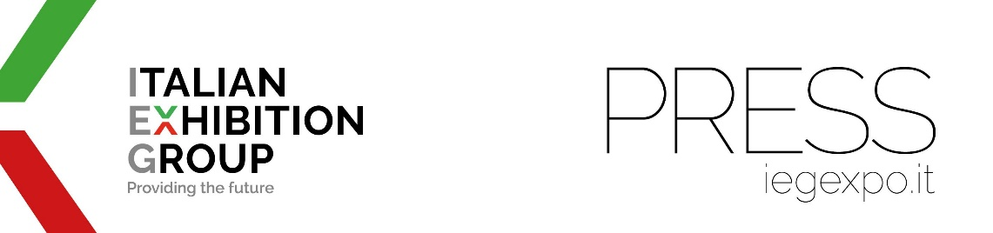

press release
(English translation)

IEG, THE FIRST GENDER EQUALITY CERTIFIED TRADE SHOW COMPANY

- A very high score obtained: 89.75 out of a range of 60 to 100
- The Certification concerns Italian Exhibition Group's Rimini and Vicenza exhibition and congress venues,
as well as the operational offices in Milan and Arezzo.
- UNI/PdR 125:2022 Certification achieved with BUREAU VERITAS ITALIA

Rimini, 30th January 2024 - Italian Exhibition Group SpA (IEG) is the first Italian trade show company to obtain the UNI/PdR 125:2022 Certification on Gender Equality due to the full correspondence of company policies aimed at work equality and the inclusion of all active employees within the company.
The certification concerns the company's Rimini and Vicenza exhibition and congress venues, as well as its operational offices in Milan and Arezzo. IEG obtained a very high score: 89.75 out of a range of 60 to 100, according to one of the highest recognised certifying agencies.
Certification is the result of an assessment process based on parameters that, starting from the foundations represented by corporate culture and strategy, looks into precise areas. The score obtained by IEG in the Certification process testifies to the well-established presence of a series of human capital management policies aimed at supporting female employment. Policies that, over the years, have created a corporate context that guarantees opportunities for growth while still maintaining a focus on work-life balance.
The consolidation of leadership regarding the issue of Diversity&Inclusion is among the sustainability objectives that the company has set itself in the recently approved Strategic Plan 2023 - 2028.

THE CERTIFYING BODY AND THE IEG TEAM
The certification process, which ended with a Bureau Veritas Italia audit, was coordinated for IEG by the HR team, led by its manager Silvia Fabbri, together with HR specialist Katia Calesini and with the collaboration of IEG's HSE coordinator Mattia Gasparini for aspects relating to integration with the numerous other certifications that Italian Exhibition Group already possesses.

STATEMENTS
“With a touch of pride,” commented IEG SpA President, Maurizio Ermeti, “I am claiming an acknowledgement that is not simply the reward for a path taken on the wave of a corporate culture that is finally asserting itself in the business world, but the affirmation of a corporate identity that has always featured a substantiated pre-requisite of rewarding and recognising talent, wherever it may be".
According to the president of Bureau Veritas Italia, Diego D'Amato, "Thanks to UNI/PdR 125:2022, companies have a formidable tool at their disposal to bring about change on the gender equality front by spreading an inclusive culture and measuring their commitment to improvement. We are proud to contribute with our certification audits to a greater awareness of gender gap issues, enhancing the commitment of companies that, like IEG, can be of example in their reference market."

IEG'S PERCENTAGE NUMBERS
IEG presented the Bureau Veritas Italia certifying body with a company snapshot of 70% female employees as proof of a DNA for which the company historically stands out and that has generated its relentless development under the banner of a virtuous relationship between inclusiveness and performance. Women in managerial roles or with area responsibilities account for 50% and those with delegated budget responsibilities amount to 51% of the total.

COMMITMENTS AND COMPETITIVENESS OF GENDER EQUALITY CERTIFIED COMPANIES
The most successful companies are those that manage to create and maintain a working model that focuses strongly on inclusiveness. Among companies that have succeeded in establishing a climate of equality and inclusion, profits are higher than average (+25-35%), there is a higher rate of innovation (+20%) and a better ability to manage decision-making processes, which translates into a +30% increase in the ability to identify and reduce business risks. Moreover, companies that adopt policies based on these values and know how to convey them externally also register benefits in terms of image and reputation (Source: Bureau Veritas Italy).
Gender Equality is one of the 17 sustainable development goals set by the UN (Goal 5); Mission 5 of the NRRP emphasises the importance of reducing inequalities, allocating EUR 9.81 billion for the development of social inclusion policies.
Moreover, as of November 2021, Law No. 162 has updated the Equal Opportunities Code and extended the obligation to prepare a report on the employment situation of men and women for all public and private companies with more than 50 employees.
The practice envisages the adoption of specific KPIs related to gender equality policies in organisations that enable the measurement, reporting and evaluation of gender-related data with the aim of bridging the gaps that currently exist, as well as embedding the new gender equality paradigm into their DNA and producing sustainable and lasting change over time.

PRESS CONTACT ITALIAN EXHIBITION GROUP | media@iegexpo.it
head of corporate communication & media relation: Elisabetta Vitali|
press office manager: Marco Forcellini | international press office coordinator: Silvia Giorgi

This press release contains forecast elements and estimates that reflect the management’s current opinions (“forward-looking statements”), particularly regarding future management performance, realization of investments, cash flow trends and the evolution of the financial structure. For their very nature, forward-looking statements have a component of risk and uncertainty, as they depend on the occurrence of future events. The effective results may differ (even significantly) from those announced, due to numerous factors, including, only by way of example: food service market and tourist flow trends in Italy, gold and jewellery market trends, green economy market trends; the evolution of raw material prices; general macroeconomic conditions; geopolitical factors and evolutions in the legislative framework. Moreover, the information contained in this release does not claim to be complete, and has not been verified by independent third parties. Forecasts, estimates and objectives contained herein are based on the information available to the Company as at the date of this release.

